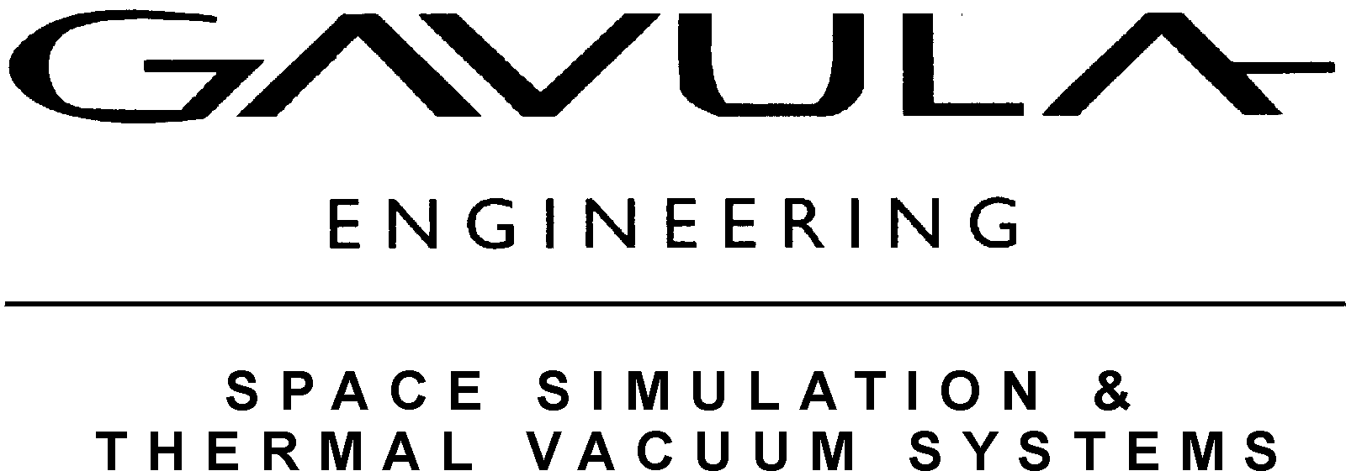

SPACE SIMULATION CHAMBER

Chamber Description: Horizontal Cylinder, 52” Ø X 50” in straight section with full opening hinged door, fabricated from 304L Stainless Steel. System was purchased from Northrop/Grumman. System was used for Thermal Vacuum Testing and exposed only to inert gases. System features a 48” Ø X 48” L, Liquid Nitrogen Shroud.
- Manufactured by BEMCO in 1996.
- Re-Conditioned and Modified by Gavula Engineering in 2012.
- Features Liquid Nitrogen Gas Shroud with 3 zones.
- Includes fabrication of Shroud Feedthru’s making the Shroud Removable.
- Chamber and Shroud have been Helium Leak Tested Good.
- Slide out stainless steel shelf inside of shroud.
- Independent platen control zone.
- Fabricated and installed new heavy duty Chamber Door Pin Hinge.
- Replaced 10” ASA Port Flange with New ISO 320, 12” Port Flange.
- Installed New ISO 320 Stainless Steel VAT Gate Valve.
- Fabricated and installed ISO 320 X ASA adapter flange collar for CTI On Board 10 Cryopump.
- Installed Re-Conditioned CTI On-Board 10 Cryopump with New CTI Model 9600 Cryo-Compressor and Helium Hoses.
- New Anest-Iwata 500C Scroll Pump (21 CFM) for Chamber Roughing and Cryopump regeneration.
- New Bellows Type Roughing and Vent Valves, 24vdc actuated.
- New NEMA enclosure vacuum control electrical panel with Allen-Bradley PLC, motor starters, relays, fuses, built by UL listed Panel Shop.
- Chamber has been pumped down to 2E -7 Torr.
Work needed to complete:
- Install quartz lamps in shroud area for high temperature testing.
- Provide new UL listed electrical panel used for thermal control using a Watlow F4T controller with 3 control circuits (Shroud cooling, Quartz Lamps Heating and Thermal plate Heat/Cool). Includes qty. 4, Watlow over/under temperature failsafe controllers. (completed).
- Install new Liquid Nitrogen solenoid valves. (completed).
- Provide new Computer for SCADA. (completed).
- Program PLC.

Price = Call for price, 805-644-8822
